- Data Science Overview
Here we are taking about some data science key features

What is Data Science?

On the surface it’s just statistics and further process, see below fig

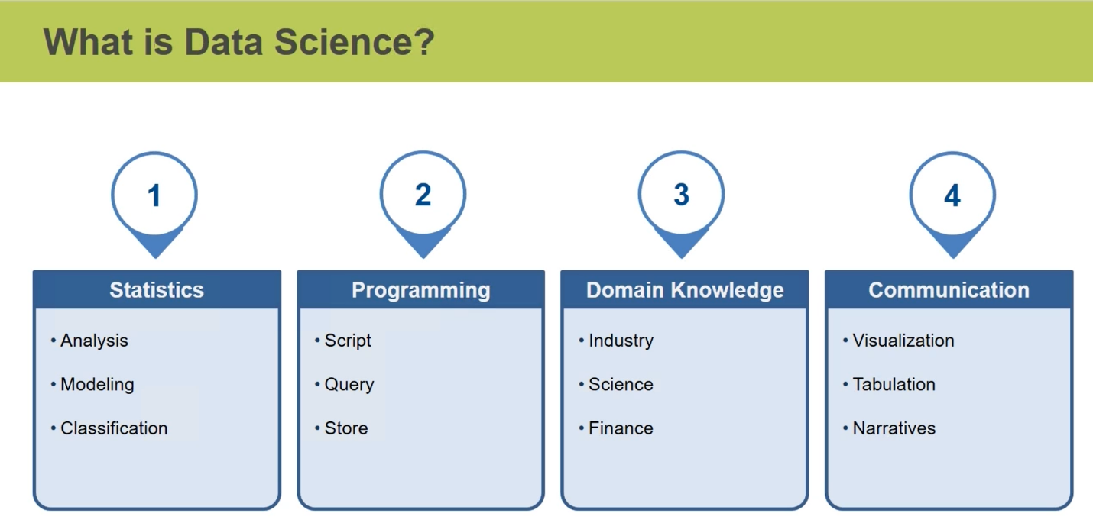

These basic process of Data sciences

Data wrangling
This is basically first step , here we gather and clean the data and this how process works
- Gather Data: can be gather by Exacting, Parsing. Scraping like video ,images rows etc.
- Filter Data: Taking Raw to data or needed data
- Convert Data: Convert (basically col as int , float string )/store data in particular format xml, json, csv, SQL
- Explore Data: Testing Data
- Integrate Data: Joining small piece to large data which as cleaned big data

Big Data
This Store all Data, we need see how to store, secure and analyze.
Software to retrieve and store

Machine Learning

Creating Statical models , as creatin a model to statical task to more accurately,

There are two type learning

1) supervise learning: this also labeled data, it takes history result data and give future predict values based on history like

Take input Past hit Movies see a make model, can tell if movie is going to be hit bases of our budget/genre/story with past data

2) Unsupervised learning: Here data is not structured, but find relation between data and make model to give accurate result.

3) Reinformed learning; This is new, same as supervised, but on correct guess we add reward system for good decision

This is basically data science we go further Deep learning , for visual we use graph etc.

Data Visualization
- Visual use for convey information in visual format like graph
- Choose correct graph depending on audience, visual data suitable for it
- Choose number rang of value, and point for good data visualization

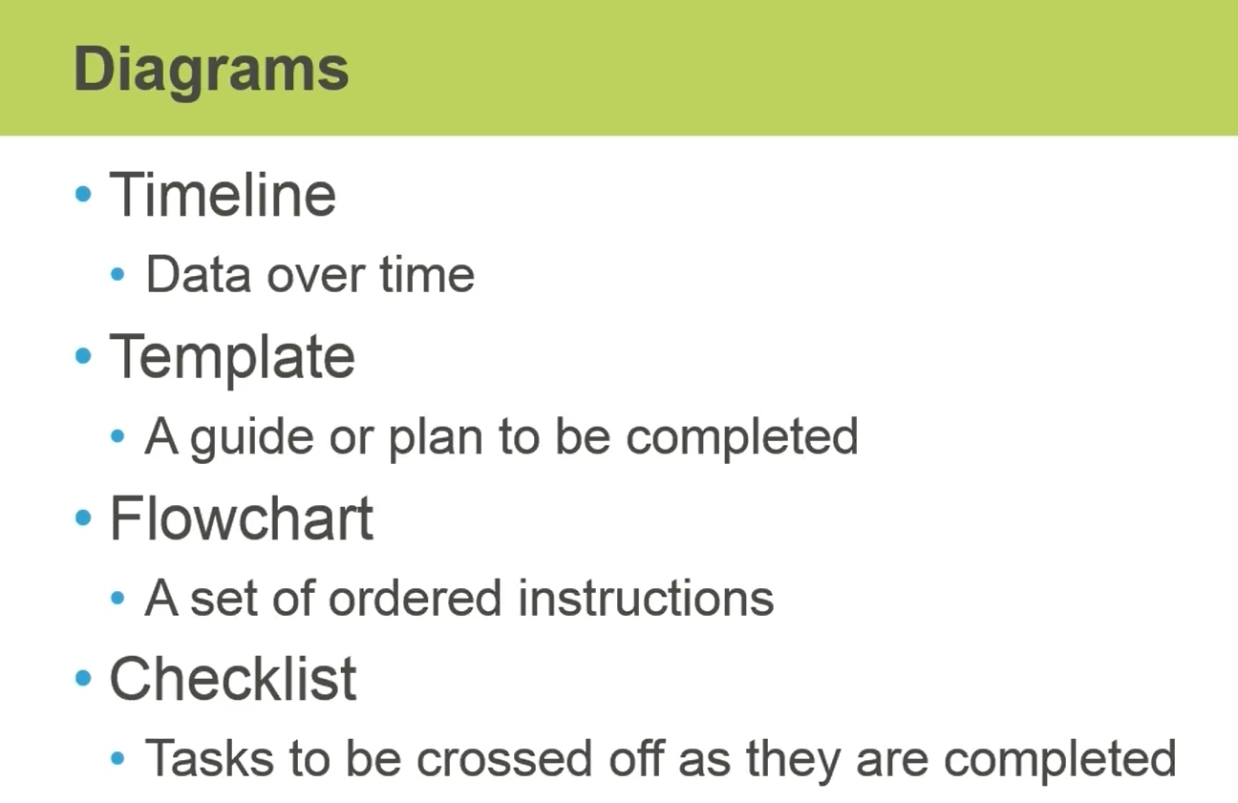

Basic types of charts and when should use
Check out these website an see more varieties of charts

https://d3js.org/
https://infoviz.org/examples/index.html
http://mbostock.github.io/protovis/ex/

Bar chart
- Use this charts for limited number of category best two
- This is best use number and comparison for excepted and original analysis
- Use colors for deafferentation is best

Line Chart
- This best see change over course of time
- Area chart will be same instead , we filled from top to bottom
- Use colors for deafferentation is best

Scatter plot
- It best to see relation between variables
- Use colors for deafferentation is best

Hierarchal Chat
- This is use for origination structure or distribution
- See example of Linux distribution
- They may be different type like radius, Node base as below ,tables etc.

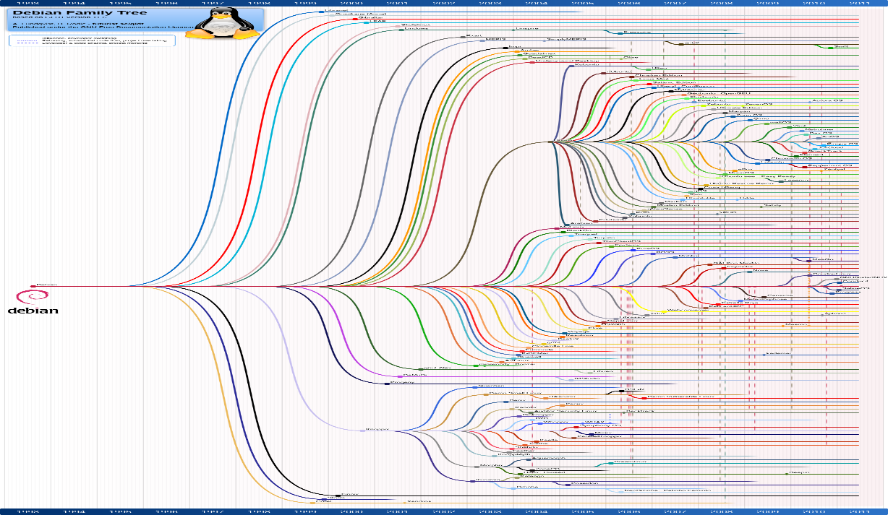
- Numpy
Numpy is array , it is use for scientific calculation , it allow data in n- form of array, and allows to transform/manipulate array

https://numpy.org/doc/stable/reference/

To us NumPy import NumPy
import numpy as np

Creation of Numpy array
To create numpy array use

P = np.arryay([ 1,3,4,4,5] , d type= )
dtype tells data type for number default is float

Can pass list also p =np.array( list )

P = np.zeros( (2,3) )
Creates a array of a zeros as 2 row and three col i.e two array inside array with three elements

P = np.ones( (2,3), dtype = np.int32 )
Creates a array of a ones as dtype integer not float, 2 row and three col i.e two array inside array with three elements

P = np.empty( (2,3) )
Creates a array of a empty array, 2 row and three col i.e two array inside array with three elements,
It s fater way to crate array

P = np.eye(4)
Creates a array as SQ matrix i.e four rows and col, diagonal as one other as zero

p = np.arange(12)
gives range of array from 0 to 12, 12 not included only 12 values

p = np.arange(2, 24)
gives range of array from 2 to 24, 24 not included

p = np.arange(2, 24,2)
gives range of array from 2 to 24, with step as 2 same as in python, can floating point also like 0.2

P = np.ones_like(array)
Creates a array of a ones as dtype shape is taken as it from array pass ed in parameter

To check row or col can check with shape

p.shape
gives array shape, result as tuple with (row, col)

p.reshape(row,col)
gives array reshape, can reshare 1d to 2d array also, bur see array reshape should all element to reorder

to print big array it will not dialy all instead give …. , to view full use
np.set_printoptions(threshold=np.nan), np.nan not an number

Array Operation on Numpy Array
Assume p is array and q is array

p + q , p-q, p*q, p/q, p//q
action perform p element by q element, like p[0] action q[0]

p *=4
each element is multiply by 4

p.dot(q) or np.dot(p,q)
vector multiplication, see https://www.mathsisfun.com/algebra/vectors-dot-product.html

p.sum(), p.min(), p.max(), p.mean()

For 2-d array give action perfom same as 1-d m takes of all values , for induvial of each row or col pass axis as 0 or 1 for row or col

Universal Function
These are values universal like

np.pi gives pi values

result = np.sin( array_degress )
gives sin degree value element by element in array_dgrees o/p as radians, similar for cos , tan ,

r = np.arcsin(result)
gives sin inverse degree value element by element in result of np.sin(array_dgrees) o/p as radians, similar for cos , tan
expo = np.exp(x)
result e^x, x, here x is array , perfom elemnt by element

np.sqrt(x) square root
np.medain(x) finds the middle value
np.var(x) finds the variance
np.std(x) finds the standard devation

np.genfromtxt(path) to read txt file

Index and slicing is same as python
For 2d arra give as

X(row , col) need spcify row slicing as 1-d and col as 1-d

Iterating And Print NumPy
P is 2-d array

p.flatten()
faltten 2d to 1d as row wsie i.e inside fisrt aryy and continue second

for data in p.faltten(order = ‘F’):
print(data)
faltten 2d to 1d as col wsie i.e inside fisrt array and continue second

To print

for data in np.nditer(p):
print(data)

print each element of 2d array as rowsie, for col wise pass order = ‘F’

for data in np.nditer(p, order = ‘F’, flags=[‘extrenal_loop’], op_flags = [‘readdwrite’]):
print(data)

flag and op_flag tells behaviour of for loop like for extrenal_loop work as normal for loop

op_flag read write as, by default we cannot perform action as it is in read mode only , to change behavior we use read write

Reshape of array
we can reshare array by reshape, flatten , there are some more function

p.ravel()
same as flatten(), but faltten wotk for numpy array , ravel() works for any object
p.T
transpose or matrix, row to col and col to row

reshape
if we pass negative value in reshape it give adjust col or row base on given positive number

in reshape we need to see all element are present , or else throes error

Split of NumpyArray

np.split(p,4)
Split the array to produce 4 equal-sized sub arrays and array should be equal splitable or else throws error

p = np.array( [ ('IBM','Apple Inc','Intel','Sony','Dell','Akamai') ,

("New York","California","California","Texas","Washington","Ohio")

] ) take as array

P=np.hsplit(array,4)
Split the array to produce 4 equal-sized sub arrays, split as colwise array should be equal splitable or else throws error

P=np.vsplit(array,4)
Split the array to produce 4 equal-sized sub arrays, split as rowwise array should be equal splitable or else throws error

np.split(array, number,axis=1) , axis = 1 for vsplit, axis =0 for hsplit

Reading Image as Array

- Using framework reads image as NumPy array,
- As image is array, can slicing image and see result

Copies Numpy Array
- Two type of copying shallow and deep
- To shallow use p.view()
- To deep use p.copy()

Index Masks
- Acesss multiple values by indexing
- P[3] fives third position value
- Mask = [1,3,5], can be 2d,ed also, result also 2d, 3d array
- P[mask], give first third and fifth position of values
- We can mask a condition also like x>6, result as 1d, for 2d, 3d give condition as in 2d or 3d
- On using np.any true if any one true , np.all true if all are true

Array Broadcasting
Doing operation on mis match arrays

- Here at atleast one dimensional should match and rest should be one
- A = (7 element) 1-d , b = (1 element), A+B works
- A = (7 element) 1-d , b = (1 element X 1 element), A+B dose not works
- A = (7 element X 3elemnet) , b = (1 element X 3 element), A+B works
- A = (7 element X 3elemnet) 1-d , b = (7 element X 3 element), A+B dose not works

